32.33: Using a Gaussian surface such that the front surface is ahead of the wave front (no electric or magnetic fields) and the back face is behind the wave front (as shown at right), we have:
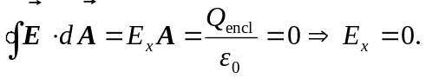
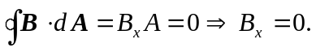
So the wave must be transverse, since there are no components of the electric or magnetic field in the direction of propagation.
